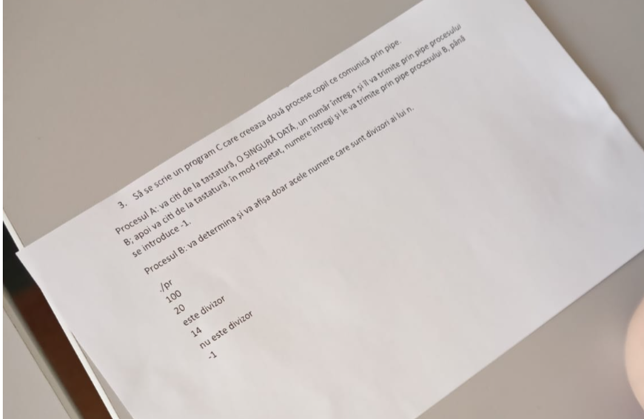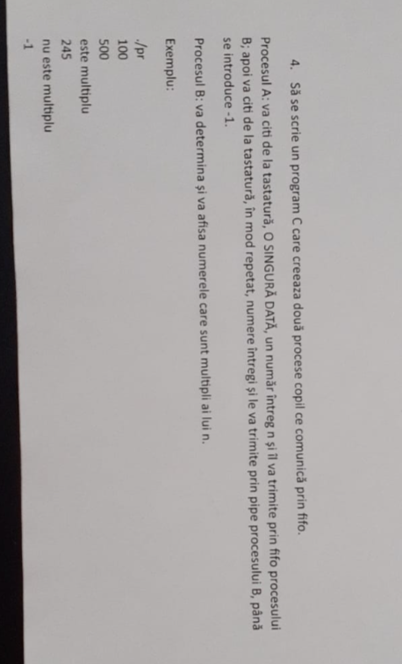



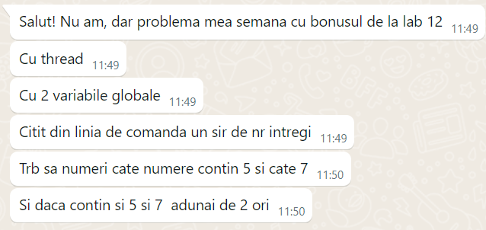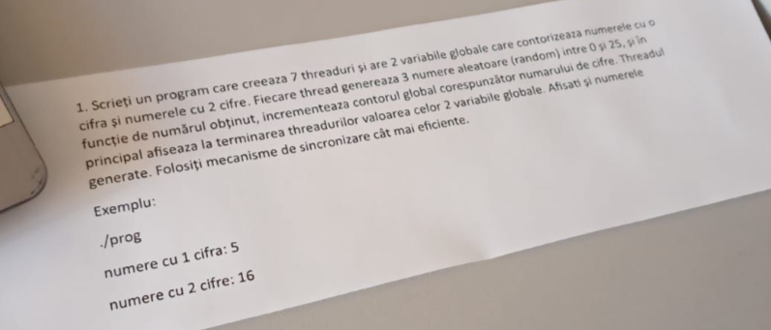



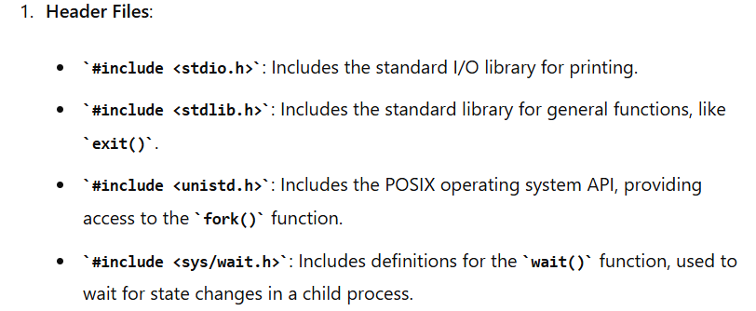

man 3 printf

man 2 open

**gcc -Wall -g -o numeexecutabil numeprogramsursa.c**

**./numeexecutabil**

INPUT/OUTPUT FUNCTIONS

int getchar(void)

int putchar(void)

char *gets(char *s)

int puts(const char *s)

int scanf(const char *format, ...)

int printf(const char *format, ...)

9. FUNCTIONS FOR WORKING WITH FILES

9.a. For text files:

FILE *fopen(const char *filename, const char *mode)

int fgetc(FILE *fp)

int fgets(char *buf, int n, FILE *fp)

int fputc(int c, FILE *fp)

int fputs(const char *s, FILE *fp)

int fclose(FILE *fp)

9.b. For binary files:

size_t fread(void *buf, size_t bsize, size_t nbyte, FILE *fp)

size_t fwrite(const void *buf, size_t bsize, size_t nbyte, FILE *fp)

or:

int open(const char *path, int oflag, ... )

ssize_t read(int fd, void *buf, size_t nbyte)

ssize_t write(int fd, const void *buf, size_t nbyte)

int close(int fd)

PROCESE

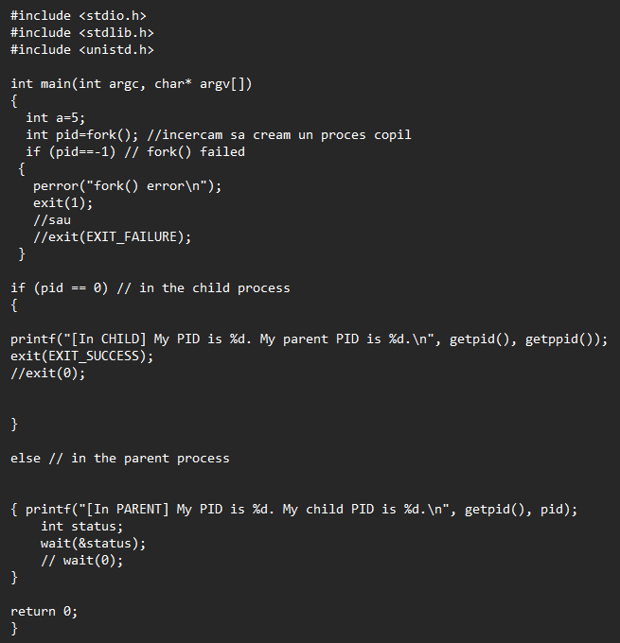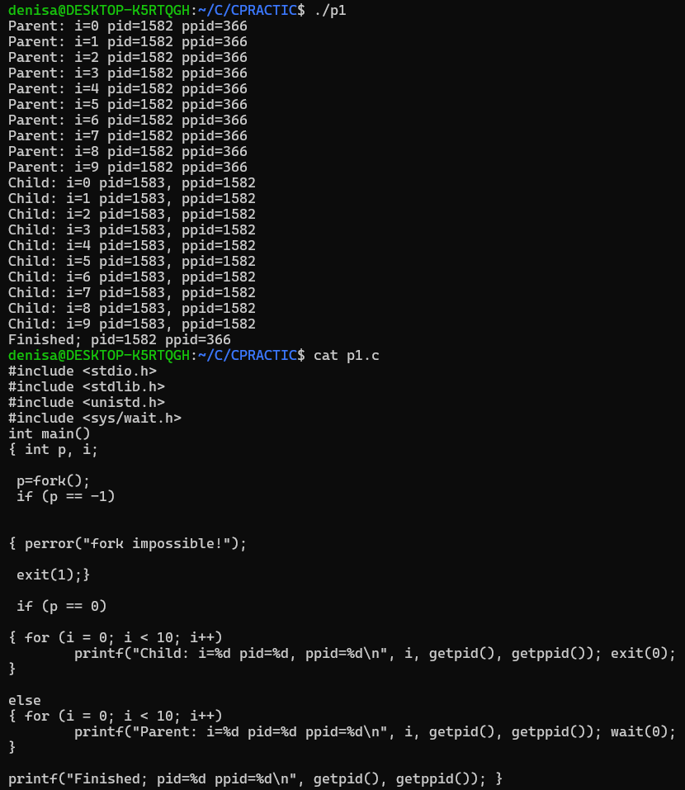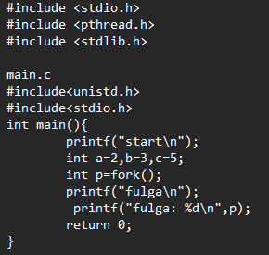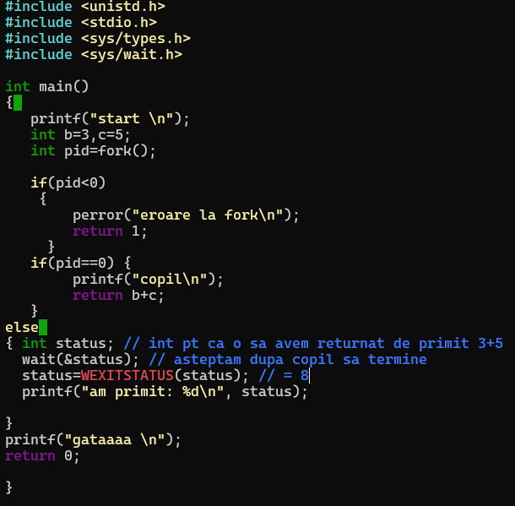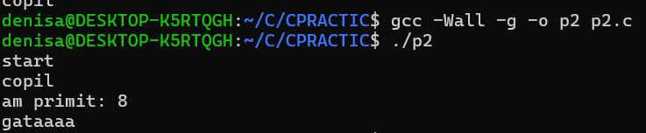

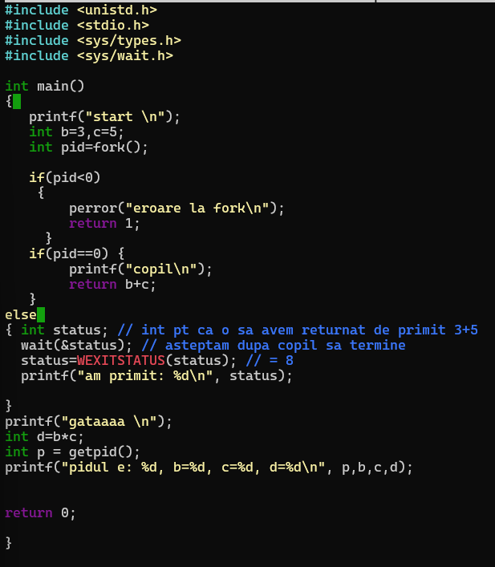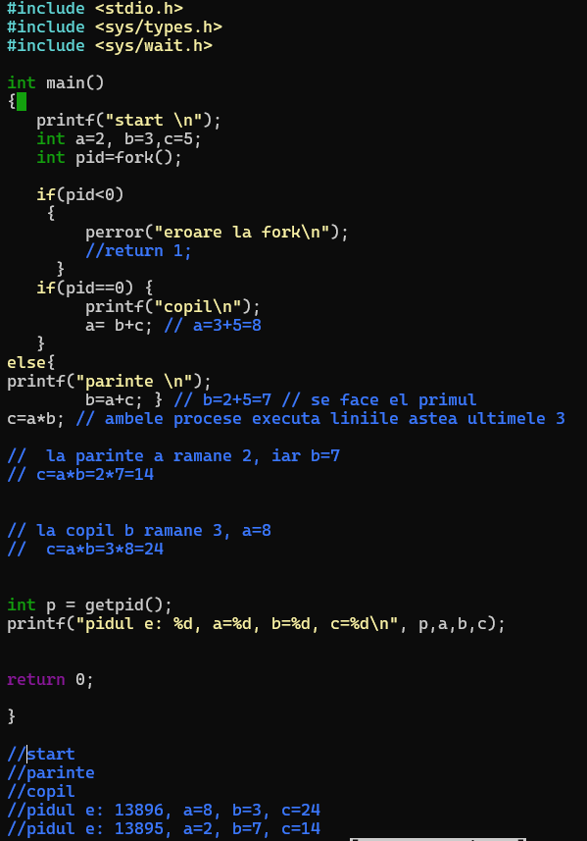

CONCURENT PARALEL

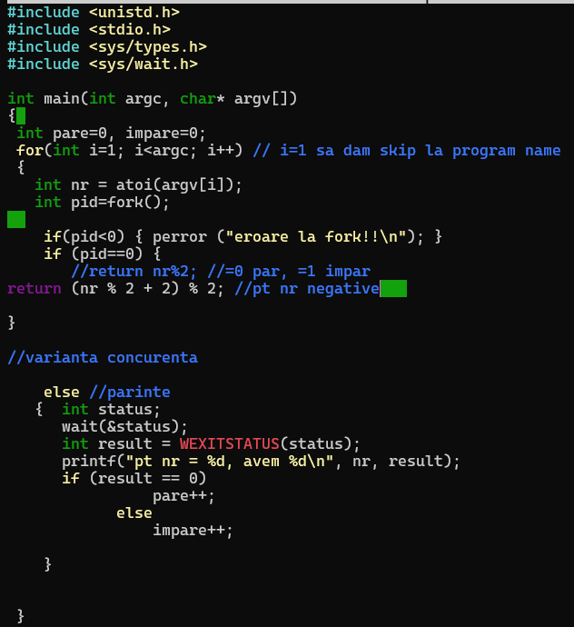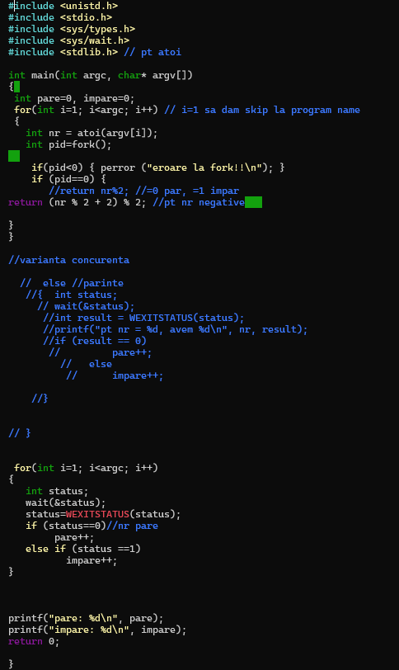

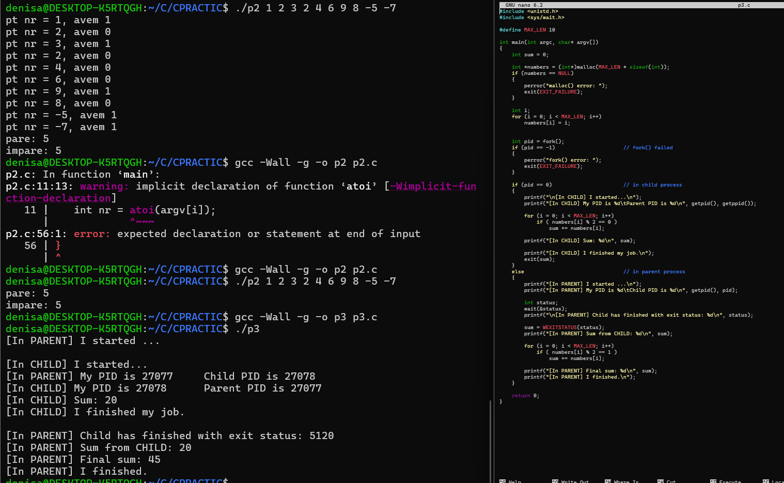

PIPE

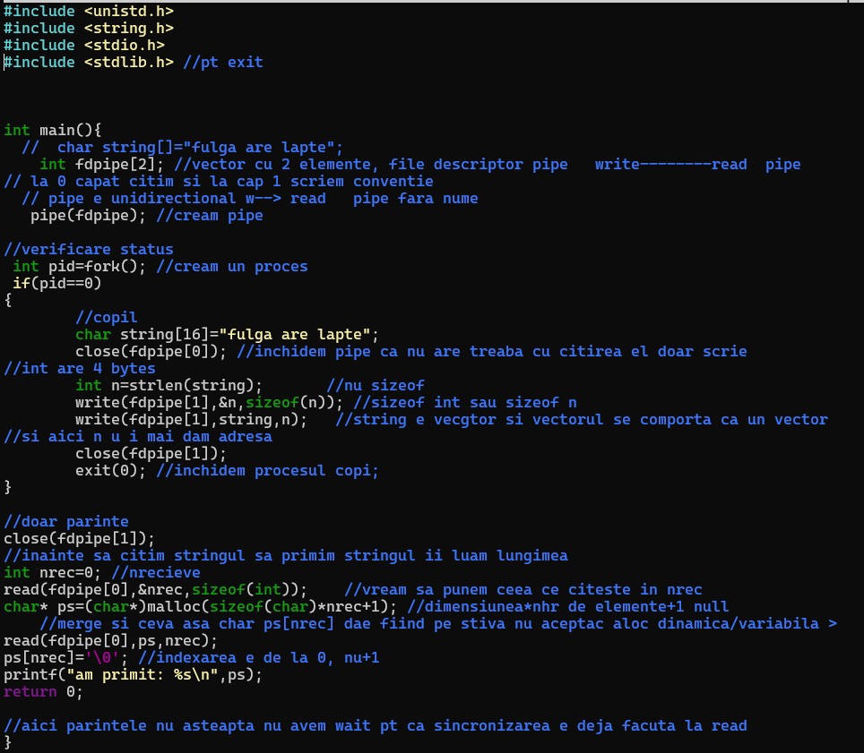

FIFO

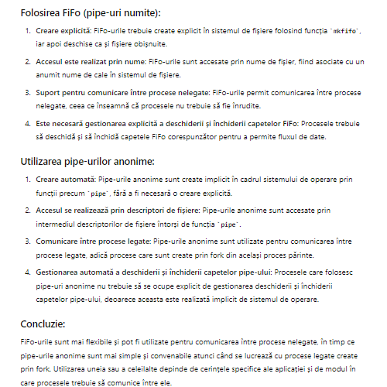

THREAD URI

